Link per video Educare nel Bosco – CanaleScuola
Intervento Davide Fattori – 20 Novembre 2023

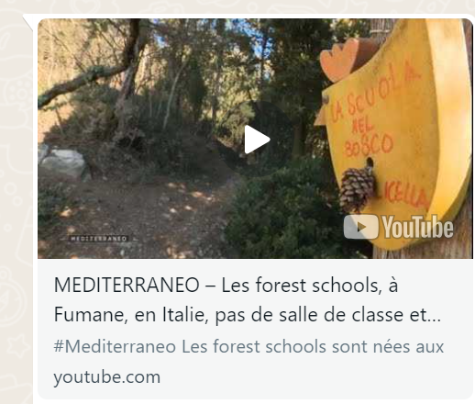
https://www.youtube.com/watch?v=p_ACKExK9vs

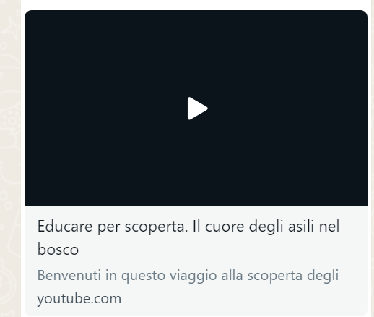
https://youtu.be/MIWBcTkeWAg?si=Qjx39IMhd-Jgv3tI

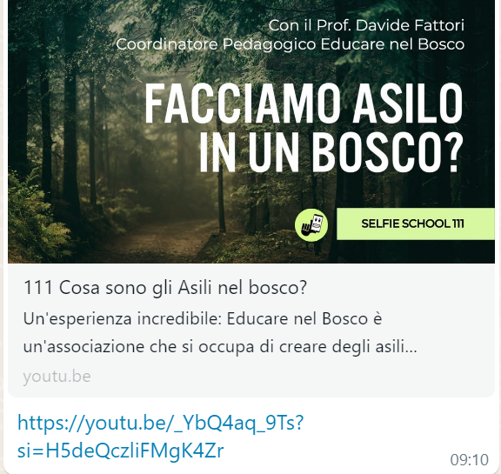
https://youtu.be/_YbQ4aq_9Ts?si=H5deQczliFMgK4Zr

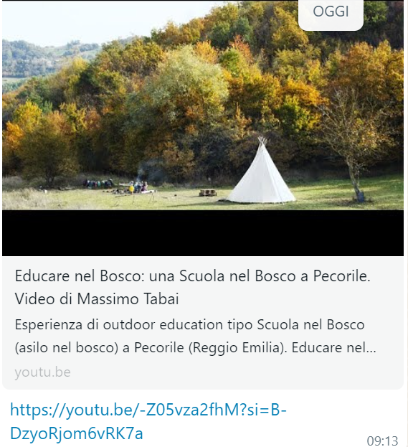
https://youtu.be/-Z05vza2fhM?si=B-DzyoRjom6vRK7a

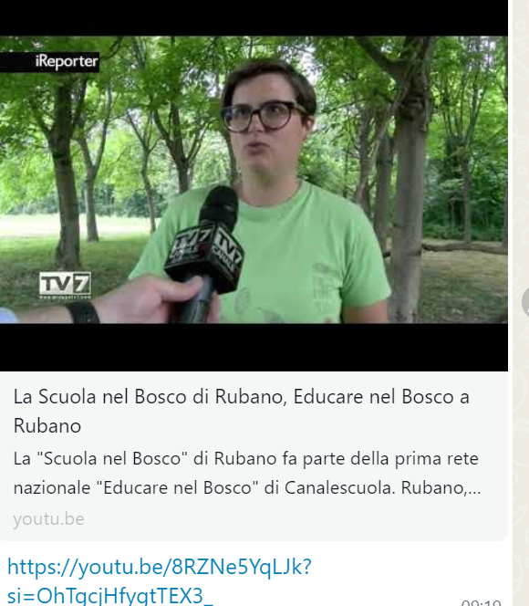
https://youtu.be/8RZNe5YqLJk?si=OhTgcjHfygtTEX3_

