MILLENIUM GOAL - EDUCATION
Obiettivi per lo sviluppo sostenibile 2030
http://www.un.org/ga/search/view_doc.asp?symbol=A/69/L.85&Lang=E
http://www.un.org/sustainabledevelopment/blog/2015/12/sustainable-development-goals-kick-off-with-start-of-new-year/
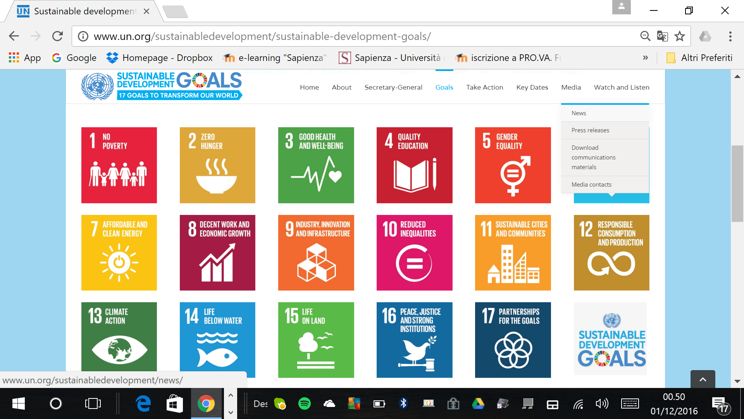

Goal 4: Ensure inclusive and quality education for all and promote lifelong learning

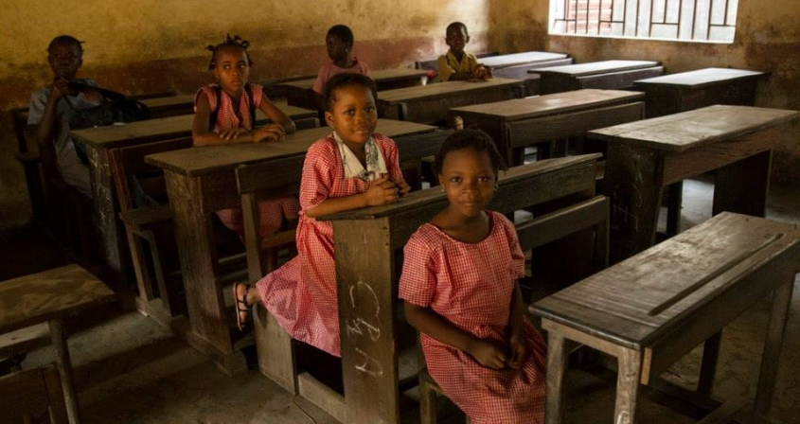
Obtaining a quality education is the foundation to improving people’s lives and sustainable development. Major progress has been made towards increasing access to education at all levels and increasing enrolment rates in schools particularly for women and girls. Basic literacy skills have improved tremendously, yet bolder efforts are needed to make even greater strides for achieving universal education goals. For example, the world has achieved equality in primary education between girls and boys, but few countries have achieved that target at all levels of education.

- Enrolment in primary education in developing countries has reached 91 per cent but 57 million children remain out of school
- More than half of children that have not enrolled in school live in sub-Saharan Africa
- An estimated 50 per cent of out-of-school children of primary school age live in conflict-affected areas
- 103 million youth worldwide lack basic literacy skills, and more than 60 per cent of them are women

GOALS

- By 2030, ensure that all girls and boys complete free, equitable and quality primary and secondary education leading to relevant and Goal-4 effective learning outcomes
- By 2030, ensure that all girls and boys have access to quality early childhood development, care and preprimary education so that they are ready for primary education
- By 2030, ensure equal access for all women and men to affordable and quality technical, vocational and tertiary education, including university
- By 2030, substantially increase the number of youth and adults who have relevant skills, including technical and vocational skills, for employment, decent jobs and entrepreneurship
- By 2030, eliminate gender disparities in education and ensure equal access to all levels of education and vocational training for the vulnerable, including persons with disabilities, indigenous peoples and children in vulnerable situations
- By 2030, ensure that all youth and a substantial proportion of adults, both men and women, achieve literacy and numeracy
- By 2030, ensure that all learners acquire the knowledge and skills needed to promote sustainable development, including, among others, through education for sustainable development and sustainable lifestyles, human rights, gender equality, promotion of a culture of peace and non-violence, global citizenship and appreciation of cultural diversity and of culture’s contribution to sustainable development
- Build and upgrade education facilities that are child, disability and gender sensitive and provide safe, nonviolent, inclusive and effective learning environments for all
- By 2020, substantially expand globally the number of scholarships available to developing countries, in particular least developed countries, small island developing States and African countries, for enrolment in higher education, including vocational training and information and communications technology, technical, engineering and scientific programmes, in developed countries and other developing countries
- By 2030, substantially increase the supply of qualified teachers, including through international cooperation for teacher training in developing countries, especially least developed countries and small island developing state

Solberg op-ed: We have real chance to make global education reality
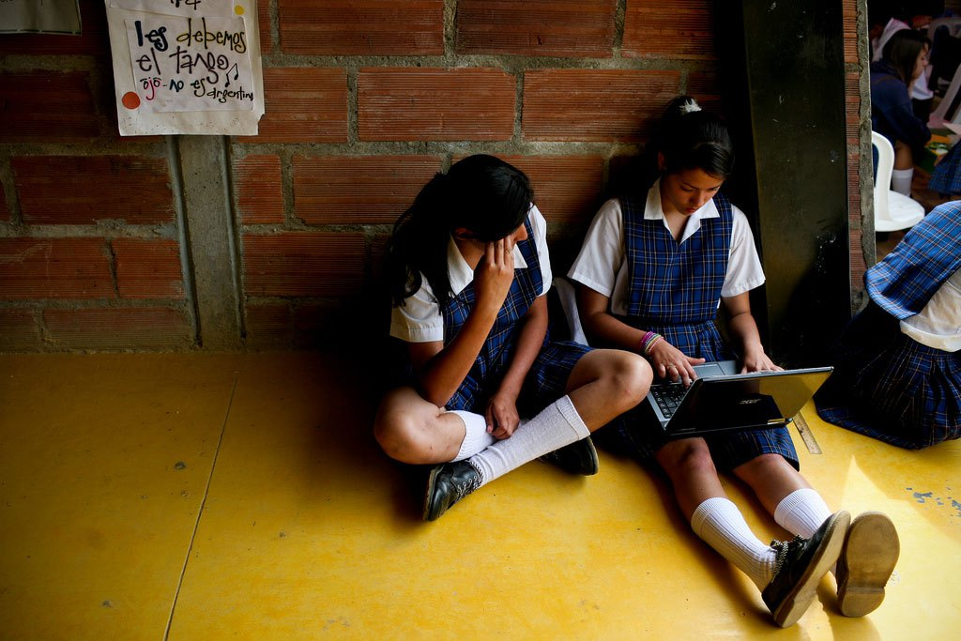
For the first time in history we can succeed in providing education for all children and young people. If we put education first, we will gain multiple benefits in terms of development and prosperity.
Political will is paramount, and must be backed by the right policies, additional funds and innovative partnerships that include all interested parties.
As prime minister of Norway and co-chair of the UN sustainable development goals advocacy group, I am doing my best to ensure this will become a reality. This week, the international commission on financing global education opportunity gathers in Oslo for its last meeting before making recommendations to the UN secretary general in September.
“Our progress as a nation can be no swifter than our progress in education,” John F Kennedy once stated in a message to the US Congress. That statement, made 55 years ago, remains just as true today, and applies to all countries regardless of their social and economic development. We all face the challenges of adapting to a rapidly changing global economy. Knowledge and innovation are probably more essential than ever before. Few – if any – investments are likely to pay higher returns over time. There is a business case for education in every corner of the world.
Take job creation and innovation.
Worldwide, there is a huge need for more and better jobs, especially with youth unemployment rising. The International Labour Organisation estimates that 600 million new jobs will be needed by 2020 in order to address global unemployment and keep up with demographic developments. Countries are dealing with this challenge in different ways, but the starting point for all of us is our education system. Well-functioning schools with qualified and motivated teachers are a prerequisite for success. Moreover, innovation and use of new technology are necessary to deliver the qualifications required by a knowledge-based labour market in constant flux.
Take gender equality and health.
If young girls are able to access and complete primary and secondary education, the number of child marriages and early pregnancies will go down, while the opportunity for women to participate in society and contribute directly to the economy will increase. Education and health are directly linked in this regard: for example, in many low- and middle income countries, increased access to education for girls has led to a significant reduction in infant mortality.
Last year, world leaders adopted the sustainable development goals. SDG 4, aiming at quality education for all by 2030, is central precisely because of its impact on health and a range of other goals and targets.
Our common task is to provide and protect quality education for the 124m children and adolescents who remain out of school, and to ensure improved learning outcomes for those who are in school. According to the UN, an estimated 125 million children are not learning basic skills even though they have spent at least four years in school.
SDG 4 may seem overwhelmingly ambitious. Yet the number of children and young people not attending school has almost halved since the turn of the century and, thanks in part to the millennium development goals, in most countries there are now as many girls as boys in primary school.
When my government took office almost three years ago, we decided to put education at the forefront of Norway’s development policy. We are in the process of doubling development aid for education, emphasising in particular girls’ education, quality and learning outcomes, vocational training and education in emergencies and protracted crises.
Although we have increased humanitarian aid for education to 8%, four times the global average, the fact remains that 37 million children and adolescents are out of school due to crises and conflict. So far, the international community has done far too little in this field. We need to find better ways of bridging humanitarian and development aid, devising more initiatives such as the education cannot wait fund – a scheme that makes provision for education in emergencies – launched at May’s world humanitarian summit in Istanbul.
Finance is a major barrier to reaching the education SDG. The total annual gap between available domestic resources and the amount necessary to reach the new education targets has been projected to average $39bn (£28bn) between 2015 and 2030.
Mobilising domestic resources is key. While the main responsibility for education rests with national governments, development aid continues to play a role, especially in the least developed countries, in fragile situations, and for marginalised groups. The downward trend in development aid for education over the past year must be reversed to ensure that no one is left behind. More of the same is, however, not sufficient. We must promote innovation and try out new approaches, such as results-based financing. The private sector should be actively involved, alongside governments, NGOs, international organisations and other stakeholders, not least when it comes to vocational training.
We need to develop a renewed and compelling investment case for education, and a financial pathway leading to universal access to quality education. That is why the international commission on financing global education, chaired by Gordon Brown, the UN special envoy for global education, was established last summer at the Oslo summit on education for development. The UN secretary general has made it clear that he will act upon the commission’s recommendations. So should we all.
Reaching all children and young people with quality education may be a daunting challenge, but we can make significant progress if decision-makers step up to the plate, together with teacher unions, international organisations, the private sector, civil society and others.
Investing in education means investing in society at large. If we put education first, our global society will reap significant gains in terms of development and prosperity.

Erna Solberg is the Prime Minister of Norway. This op-ed originally appeared in the Guardian.

UNICEF report: Growing inequalities threaten most disadvantaged kids
- 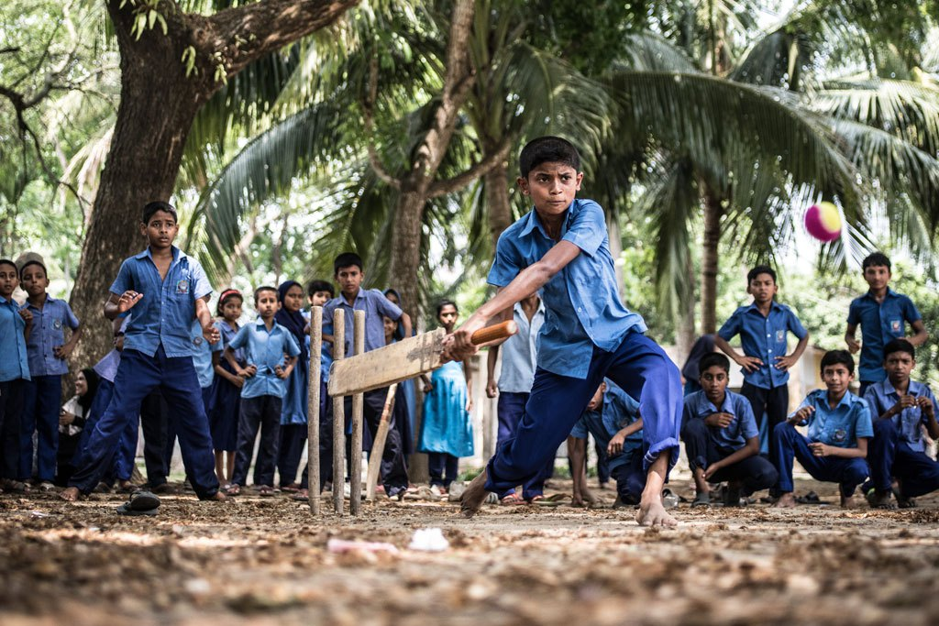

Some 69 million children under five years of age will die from mostly preventable causes, 167 million children will live in poverty, and 750 million women will have been married as children by 2030, unless the world focuses more on the plight of its most disadvantaged children, according to a United Nations report published today.
“Denying hundreds of millions of children a fair chance in life does more than threaten their futures – by fueling intergenerational cycles of disadvantage, it imperils the future of their societies,” said the Executive Director of the UN Children’s Fund (UNICEF), Anthony Lake, on the release of The State of the World’s Children, the agency’s annual flagship report.
“We have a choice: Invest in these children now or allow our world to become still more unequal and divided,” he added.
The report notes that significant progress has been made in saving children’s lives, getting children into school and lifting people out of poverty. Global under-five mortality rates have been more than halved since 1990, boys and girls attend primary school in equal numbers in 129 countries, and the number of people living in extreme poverty worldwide is almost half what it was in the 1990s.
But this progress has been neither even nor fair, the report flags. The poorest children are twice as likely to die before their fifth birthday and to be chronically malnourished than the richest.
Across much of South Asia and sub-Saharan Africa, children born to mothers with no education are almost three times more likely to die before they are five than those born to mothers with a secondary education. And girls from the poorest households are twice as likely to marry as children than girls from the wealthiest households.

Outlook worst in sub-Saharan Africa
Nowhere is the outlook grimmer than in sub-Saharan Africa, where at least 247 million children – or two in three – live in multidimensional poverty, deprived of what they need to survive and develop, and where nearly 60 per cent of 20- to 24-year-olds from the poorest fifth of the population have had less than four years of schooling. At current trends, the report projects, by 2030, sub-Saharan Africa will account for:
- Nearly half of the 69 million children who will die before their fifth birthday from mostly preventable causes;
- More than half of the 60 million children of primary school age who will still be out of school; and
- 9 out of 10 children living in extreme poverty.
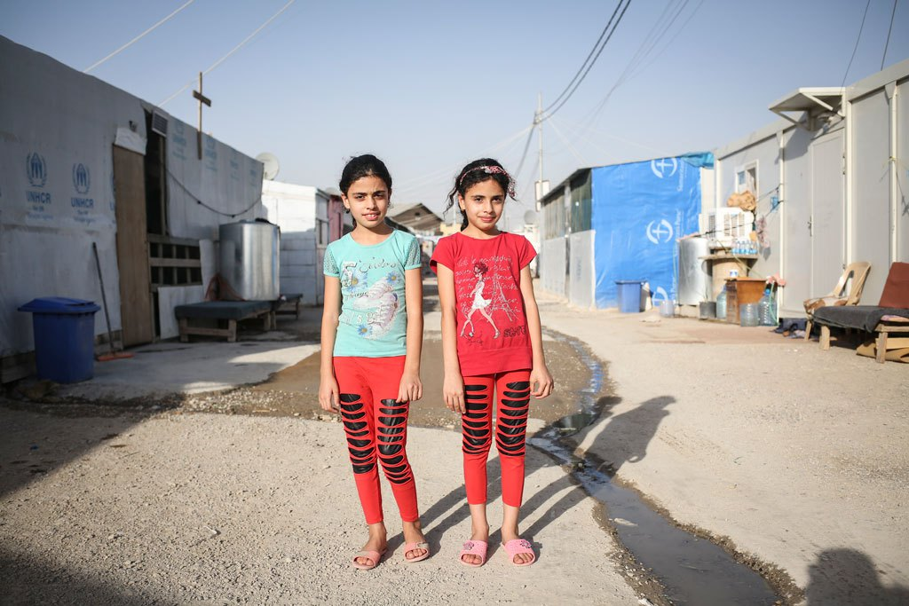
Maryam, 10, (right) poses for a photo with her twin sister Majida outside their caravan in a camp for displaced families in Erbil in the Kurdistan region of Iraq on May 24, 2016. Photo: Photo: UNICEF/Tara Todras-Whitehill
The UNICEF report goes on to note that although education plays a unique role in levelling the playing field for children, the number of children who do not attend school has increased since 2011, and a significant proportion of those who do go to school are not learning.
About 124 million children today do not go to primary- and lower-secondary school, and almost two in five who do finish primary school have not learned how to read, write or do simple arithmetic.

Investing in children pays off
The report points to evidence that investing in the most vulnerable children can yield immediate and long-term benefits. Cash transfers, for example, have been shown to help children stay in school longer and advance to higher levels of education.
On average, each additional year of education a child receives increases his or her adult earnings by about 10 per cent. And for each additional year of schooling completed, on average, by young adults in a country, that country’s poverty rates fall by nine per cent.
Inequity is neither inevitable, nor insurmountable, the report notes, pointing out that better data on the most vulnerable children, integrated solutions to the challenges children face, innovative ways to address old problems, more equitable investment and increased involvement by communities are all measures which can help level the playing field for children.
The Sustainable Development Goals (SDGs), adopted last year by 193 UN Member States, aims by 2030 to eradicate poverty and ensure inclusive and equitable quality education and promote lifelong learning opportunities for all, among other objectives.
via UN News Centre
June 28th, 2016|Education, Inequality, News, Poverty, Sustainable Development Agenda

UN conference adopts global education action agenda to mobilize civil society
- 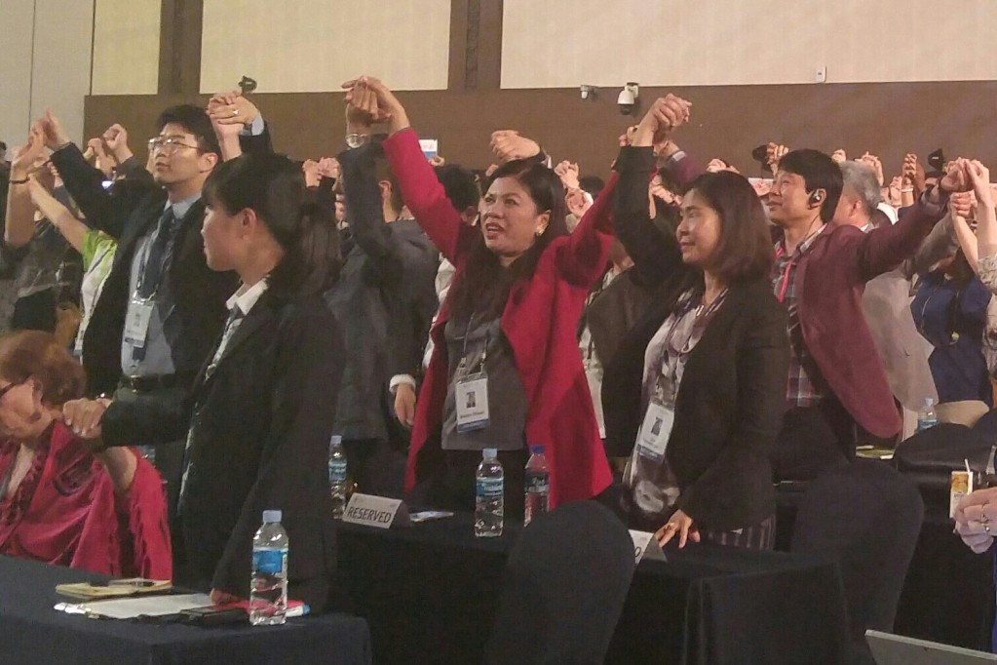

A global education action agenda affirming the importance of Sustainable Development Goal 4 – ensuring inclusive and equitable quality education and promoting lifelong opportunities for all – was adopted today in Gyeongju, Republic of Korea.
Speaking from the podium at the 66th United Nations Department of Public Information (DPI)/Non-Governmental Organization (NGO) Conference, Ms. Cristina Gallach, UN Under-Secretary-General for Communications and Public Information, said “This Conference has demonstrated another example of the value for the United Nations in investing in partnership with academia and NGOs.”
The Gyeongju Action Plan provides concrete guidance for NGOs around the world to enhance their ability to lobby governments to commitment to implementing the SustainableSustainable Development Goals and mobilize NGOs in communities on the ground.
“The United Nations is committed to continue to support and partner with NGOs and academia in our joint efforts to advocate for and successfully implement the 2030 Agenda,” Ms. Gallach continued.
The newly adopted Action Plan includes a series of concrete measures for NGOs around the world to jump-start implementation of the 2030 Agenda at the grass roots level.
Dr. Scott Carlin, Conference Co-chair and Associate Professor of Geography at Long Island University, said “NGOs from around the world brought passion and expertise to lively final consultations on the outcome document. We are grateful for all of the inputs received and very proud of the Gyeongju Action Plan.”
“We hope that Gyeongju was an inspirational setting for finalizing a truly unifyingaction plan that will be useful for NGOs, wherever they are working,” added Co-Chair Dr.Yukang Choi.
For the first time in the history of the DPI/NGO Conference, youth also developed and issued a Youth Declaration.
Ms. Gallach pointed out that youth had “come in great numbers, demonstrating the value that they see in partnering with the United Nations.”
Ahmad Alhendawi, the Secretary-General’s Envoy on Youth, noted “the Conference not only reinforced the critical role of NGOs to achieve a vision for the 2030 Agenda, but also stressed the urgency for greater investments in education for Global Citizenship to unlock the potential of this massive generation of children and youth.”
“Unfortunately youth are still not involved enough in policy making processes around the world,” said Ms. Saphira Rameshfar, UN representative of the Ba’hai Community and Conference youth leader.
“The Youth Declaration is a necessary reminder that young people are needed as leaders and decision-makers not only in youth forums and special-purpose councils, but in those spaces where the course and direction of society as a whole are determined,” added Ms. Rameshfar.
The Action Plan was drafted through a global multi-stakeholder consultation process, leading up to, and during the conference. It was adopted at the Conference’s final plenary session and will be shared widely with civil society as well as the UN Secretary-General, the UN System, Member States and learning communities.
June 1st, 2016|Education, News

‘You have unlimited power’ Ban tells youth, rallying support for SDGs
- 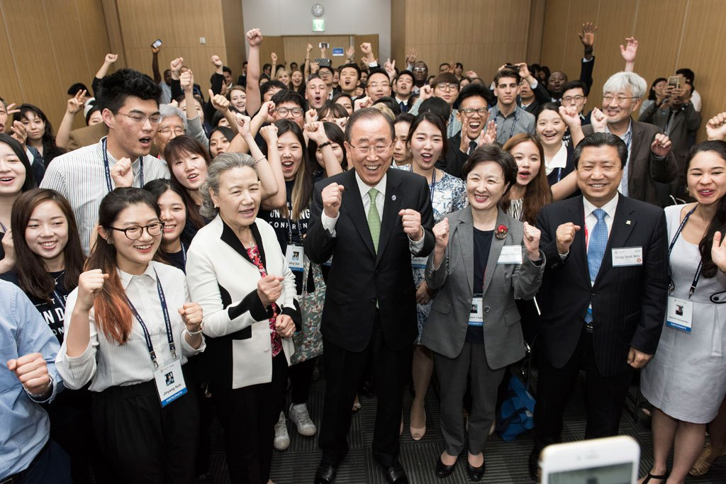
On first day of the sixty-sixth United Nations Department of Public Information/Non-Governmental Organizations Conference in Gyeongju, Republic of Korea, Secretary-General Ban Ki-moon urged youth to continue to raise their voices in pushing governments to implement the 2030 Agenda for Sustainable Development.
“You have unlimited power, unlimited authority, legitimate prerogative to raise your voice. Make your governors, mayors, national assembly members – even professors and business communities – make them accountable,” he said at a youth caucus event.
In a room filled to capacity, the UN chief urged youth to think about the circumstances in which people in other parts of the world live – underscoring the importance of tempering passion with empathy.
“Without compassion, the world would be strange and miserable,” Mr. Ban said. “Passion without compassion will lead to a strange way, undesirable way, sometimes destructive way and tragic way. When you have too much passion, that’s what happens in many parts of the world. Therefore, passion should be accompanied with compassion […] that’s my message to you.”
Mr. Ban also told the group that while they should be proud to be young, they must also be prepared for tomorrow.
Noting that his tenure as UN chief will end soon, he said, “who knows that [maybe] one of you will become Secretary-General of the United Nations,” he said to thunderous applause.
Before the UN chief arrived, Juan Pablo Celis, Conference Co-chair of the Youth Sub-committee and NGO Youth Representative of the New York UN Association, told his peers that for the next three days, issues that linked education with conflict situations, youth employment and the Sustainable Development Goals, among others, would be discussed “through very creative and innovative methods, such as performances, technological interactions and live surveys.”
And then he prompted everyone to be energetic, saying: “We are the youth of the conference and we have to be ready to make some noise!”
Via UN News Centre
May 30th, 2016|Education, News, Youth

Video

From the football field to the classrooms of Nepal | UNICEF
https://youtu.be/N29F3TD_LsE

Educating the next generation of a Madagascar family | UNICEF
https://youtu.be/A53NK6DJzVw

Bridging the education gap in Bangladesh | UNICEF
https://youtu.be/RUYsAAUkQ_E

MDG #2: Education
https://youtu.be/wGGFByWL3Yk

Portugal: Youth Emigration
https://youtu.be/cGg9ogvscEg

Adolescent girl club in Sierra Leone tackles teenage pregnancy and engenders independence
https://youtu.be/-V58LxT4TkU

LINKS

UN Educational, Scientific and Cultural Organization
UN Children’s Fund
UN Development Programme
Global Education First Initiative
UN Population Fund: Comprehensive sexuality education

